SCHOOL OF ENGINEERING
PROJECT WEEKLY PROGRESS REPORT
Name : Lee Dong Geon | Admin No :  242558W | Module Code : | Week No :  1 | Date of Monday :  9/3/2026
Objectives of the Week :

This week’s objective was to start building AI resume screening while keeping the overall project goals in mind. The main focus was to find a suitable LLM API and see how it could be used to analyse resumes and compare them with a job description. I had to look into different LLM providers and understand their strengths, especially in areas such as reasoning, text analysis, and NLP.

Another objective was to start developing the first version of the code for the project. I implemented basic text preprocessing for the resumes and the job description. The point of preprocessing was to clean and standardize the text so that the models could analyse the resumes effectively. Some of the preprocessing steps included removing unnecessary characters, normalising the text format, and keeping important information such as skills, work experience, and education details.

I also explored and compared how different LLM APIs performed when evaluating resumes. The goal was to understand how each model assesses a candidate’s suitability based on the job description. By having more than one model to evaluate the same CV, the system can potentially give more reliable results and improve the accuracy of the candidate screening process.

Objectives Achieved and Work Done :
During this week, I do feel like I made good progress. The first step was to research the different LLM APIs used to analyse resume text and evaluate candidates. After exploring several options, four LLM APIs were chosen for testing: Gemini, Cohere, Groq, and Hugging Face. I used these models because they have strong natural language processing abilities and also allows me to test and compare multiple LLM models.
After the research stage, the resume screening was implemented in Google Colab. I loaded the datasets/resume that was sent to me together with the job description with requirements for the position. Before sending the data to the language models, I used text preprocessing for the resumes and job description. I converted all text to lowercase, removed unnecessary special characters, and normalised extra spaces. This cleaned up the text so that the models can focus on the important information such as skills, experience, and job roles.
Next, I set up API connections for the selected LLM providers. Prompts were written to guide the models to analyse each resume and compare it with the job description. I asked the models to give structured responses, a summary of the candidates, a list of matching skills, possible missing or weaker areas, and a suitability score out of 10.
To evaluate the candidates, each CV was sent to all four LLM APIs. The responses were then collected and they gave a suitability score for each candidate. I used a comparison method to see which CV the models recommended the most. I also implemented a majority voting and average scoring method to make the results clearer. This makes it so that it does not have a risk of just having one model selecting everything and having a lot of inaccuracies.
Overall, the objectives for this week were achieved. The project now has a working resume screening pipeline that can process CVs, apply preprocessing, connect to multiple LLM APIs, and show candidate recommendations based on what the model shows. I think that it is a good foundation and preparation for RAG and LangChain.

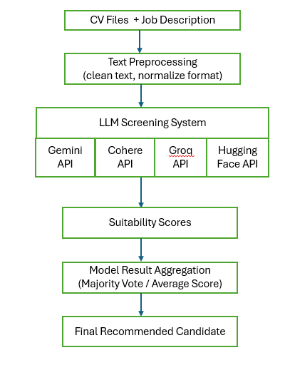
System Architecture Diagram

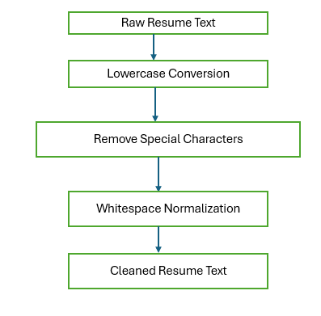
Text preprocessing Diagram

Supervisor’s Comment :

_____________________
Date/Signature

